**Screenshot of Wireshark capture summary page**

1. **For 10 KB file (File name: file10KB.txt)**

* **Summary**

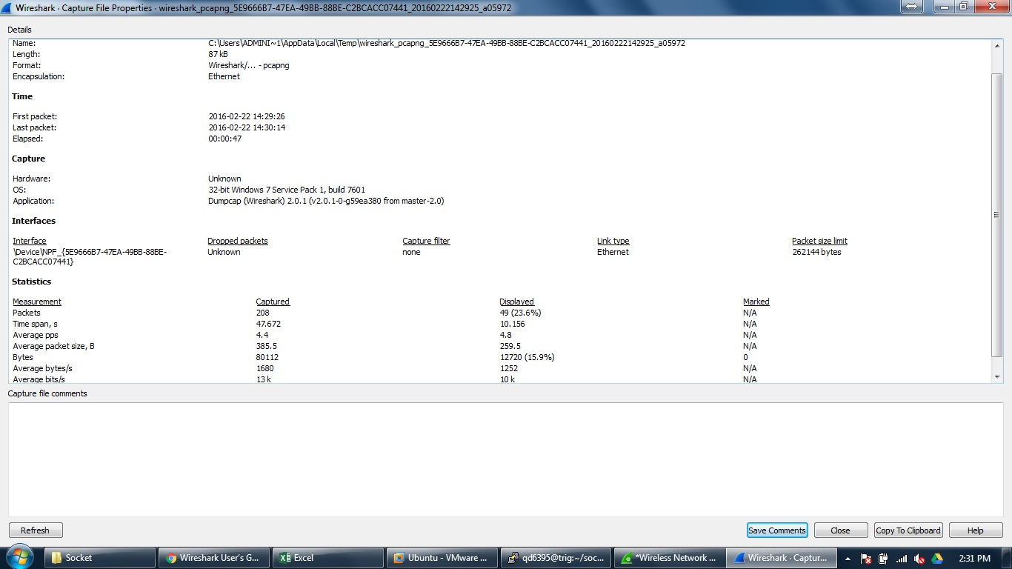

* **Capture log**

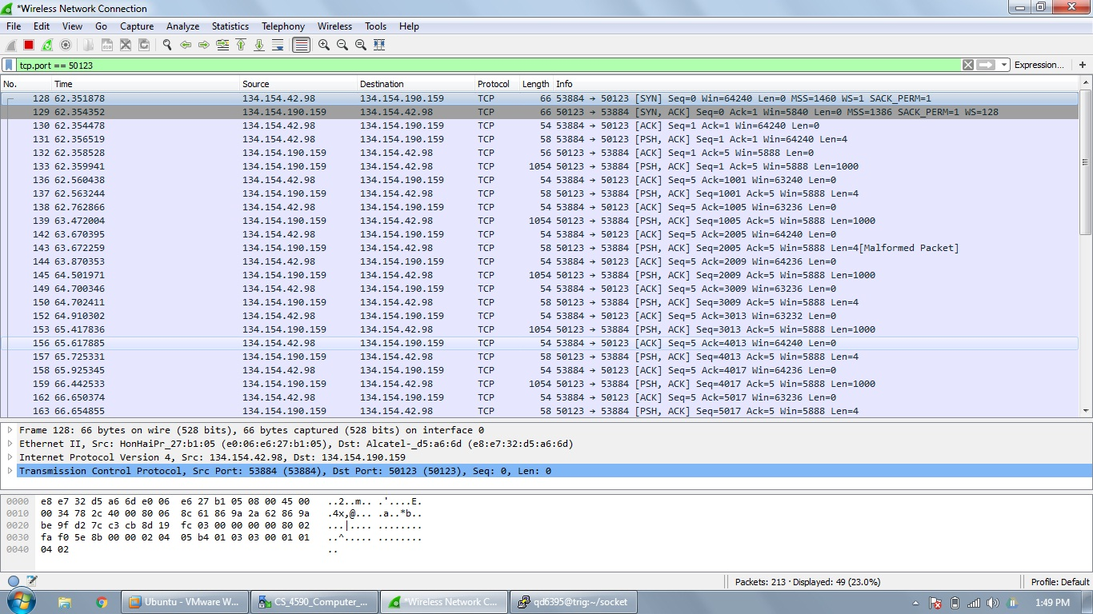

1. **For 20 KB file (File name: file20KB.txt)**

* **Summary**

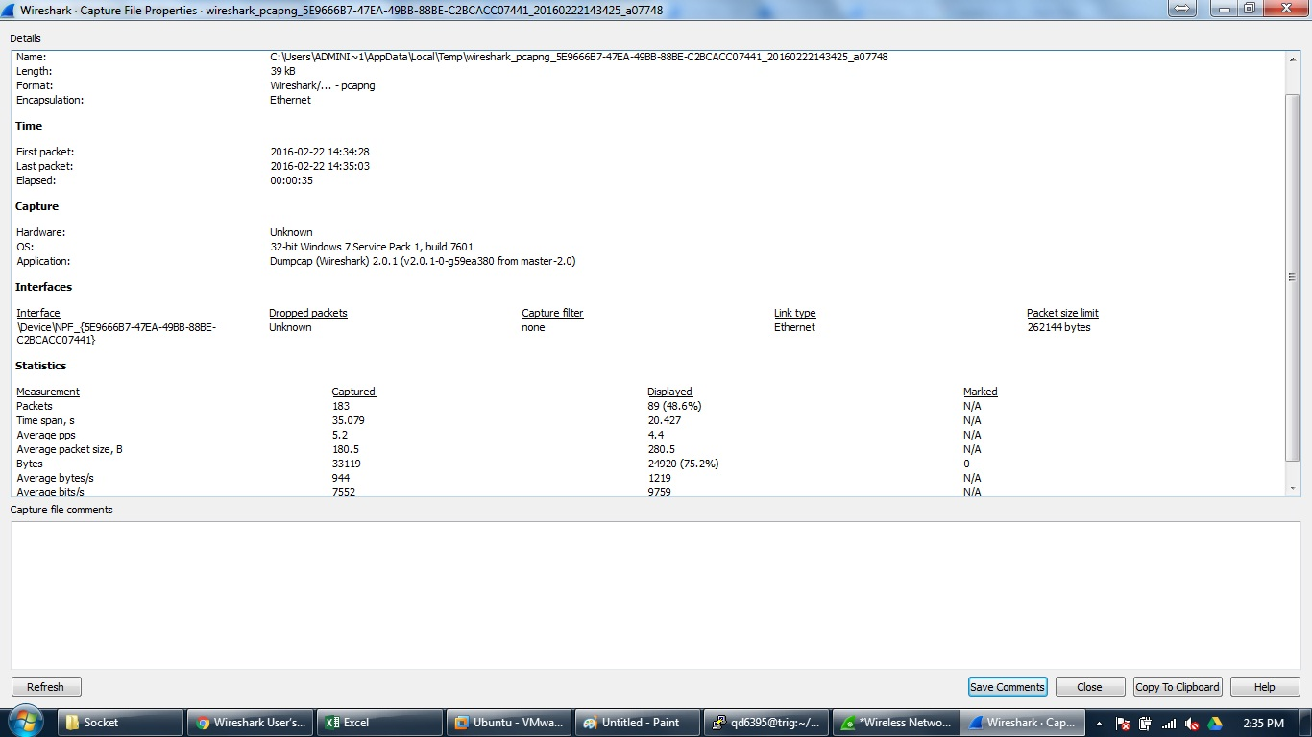

* **Capture log**

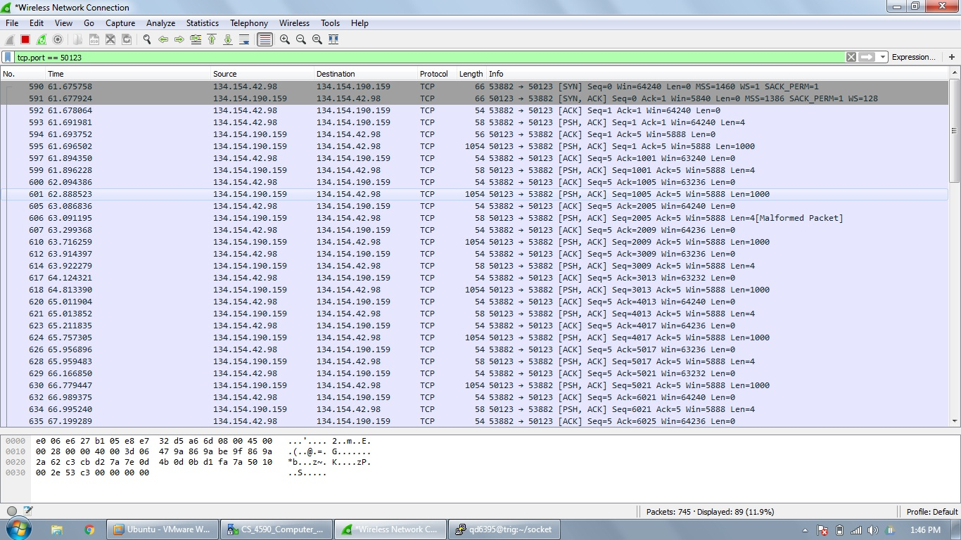

1. **For 30 KB file (File name: file30KB.txt)**

* **Summary**

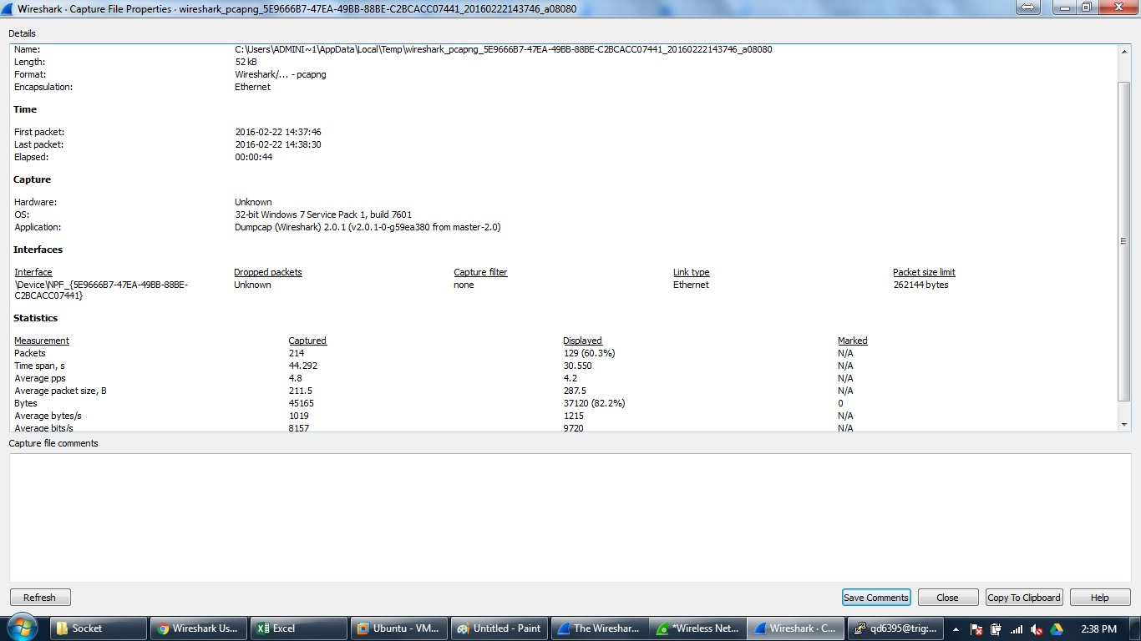

* **Capture log**

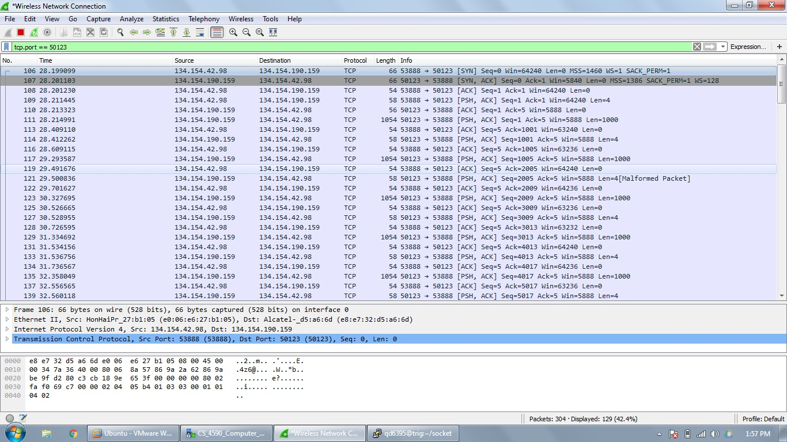

1. **For 40 KB file (File name: file40KB.txt)**

* **Summary**

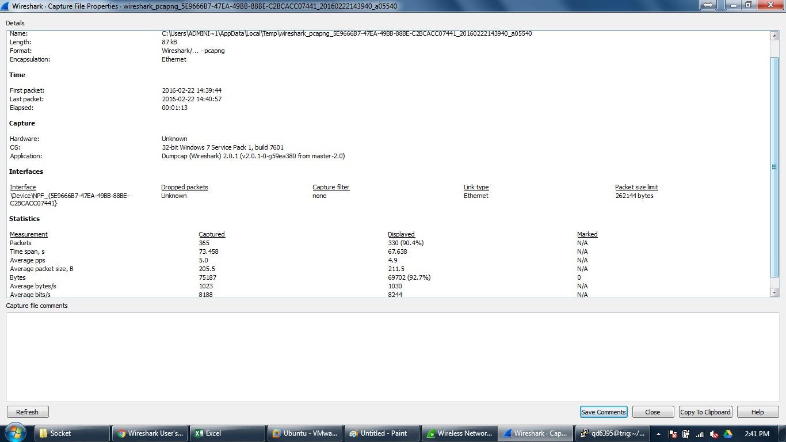

* **Capture log**

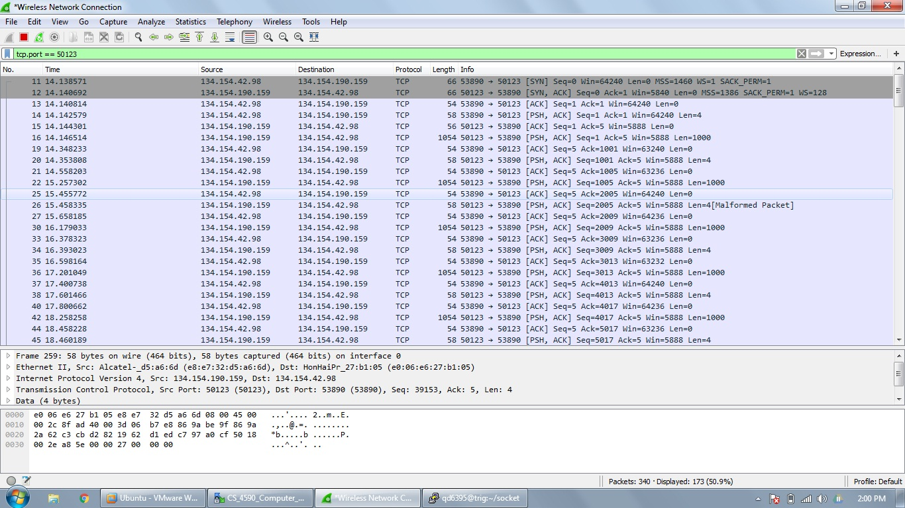

1. **For 50 KB file (File name: file50KB.txt)**

* **Summary**

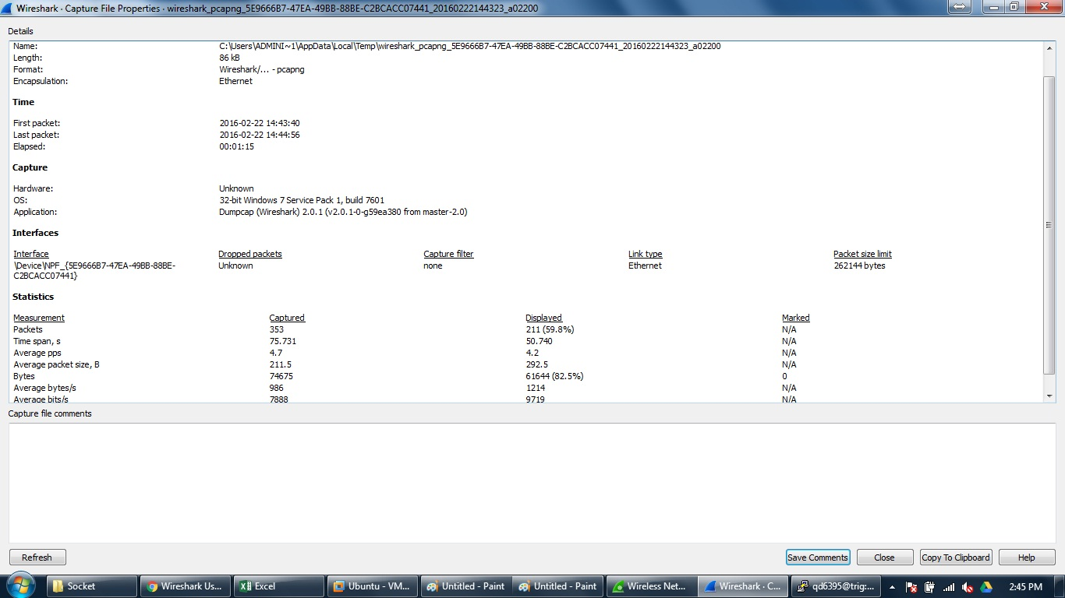

* **Capture log**

